Assignment week 7,8 Prototype design and testing.

Report

Description:

Our motivation was driven by us ourselves as newcomer to Eindhoven we struggled a lot in finding shops that are budget friendly with good quality products. The application is especially created for international students that are newcomers to Eindhoven. Our idea is to help the newcomers to easily find all the necessary shops they desire with just one tap. We selected shops that we believe are budget friendly and also offer a variety of products that have great quality. We believe that the application will help if not every then most of the international students that are coming to Eindhoven and that it will actually help them with their new journey .

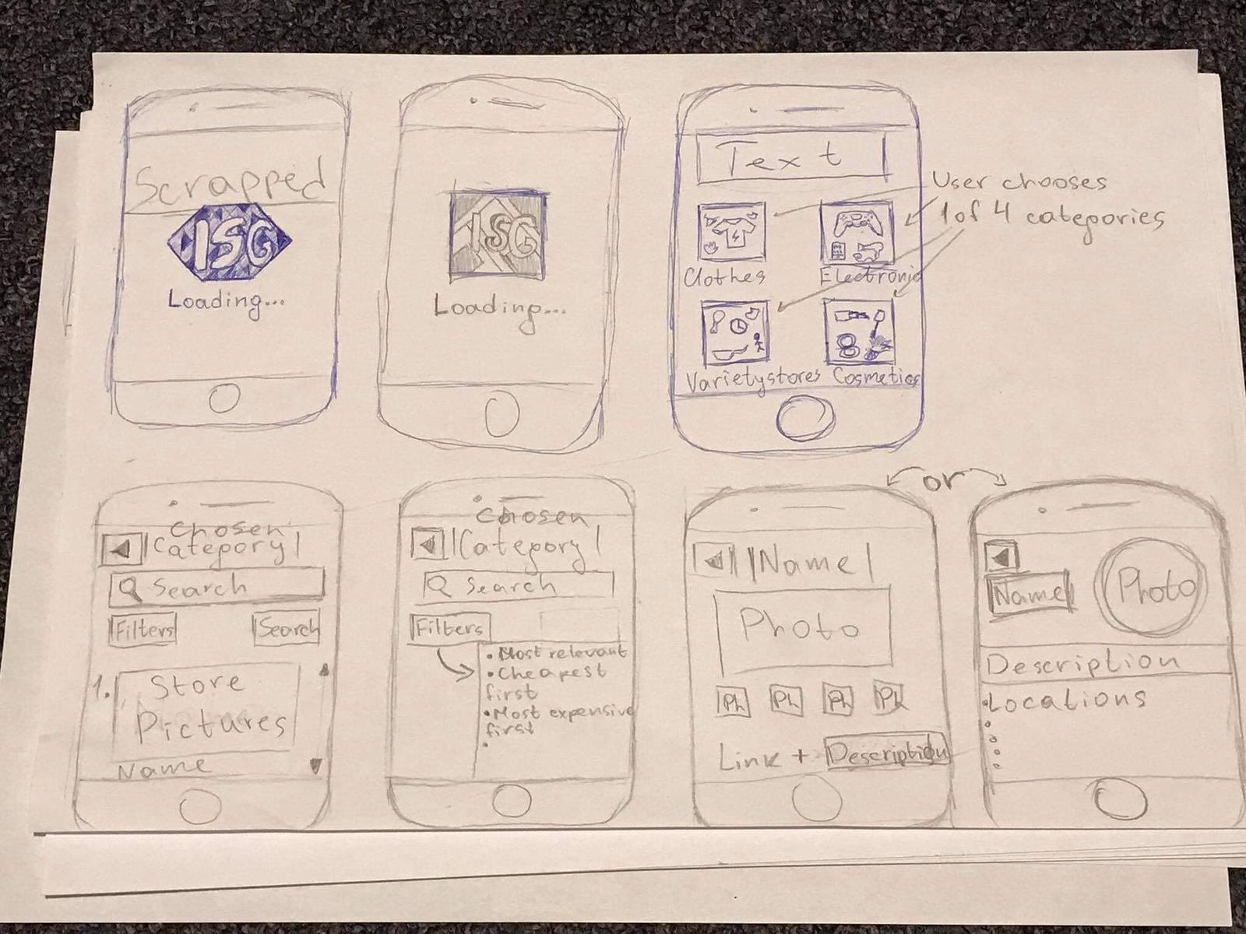Sketch:

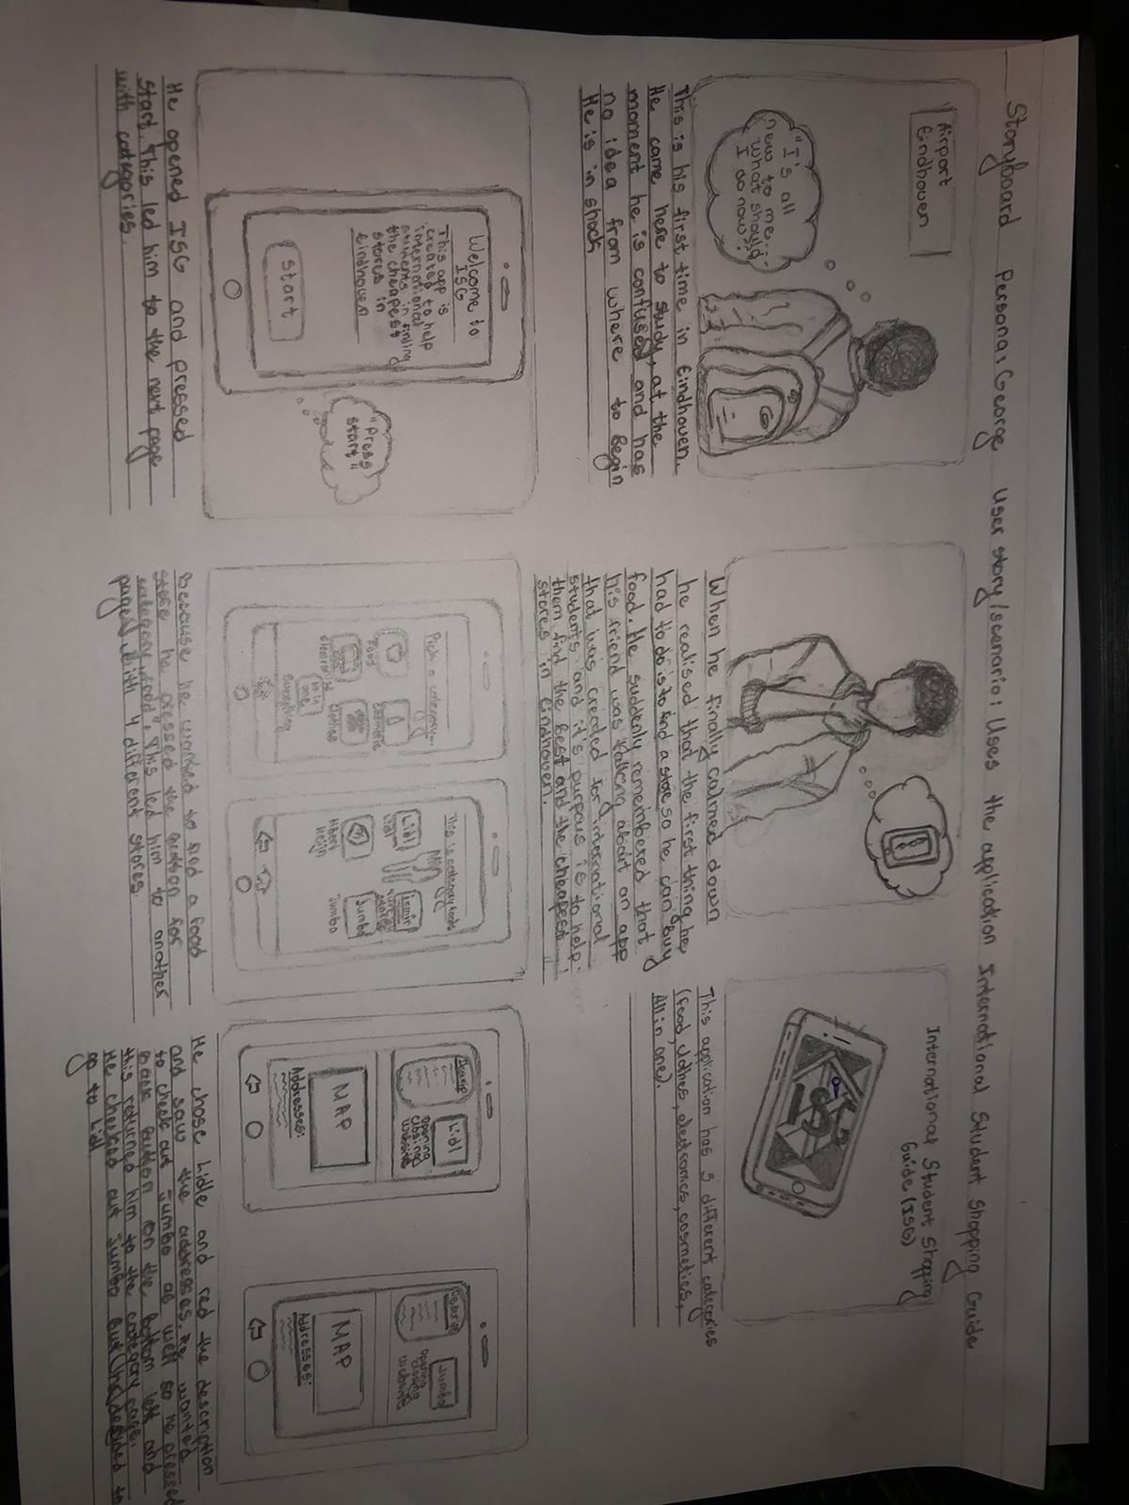Story Board:

Wireframe:

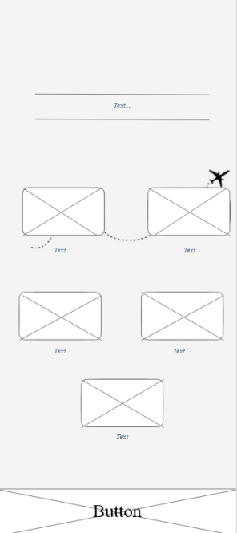

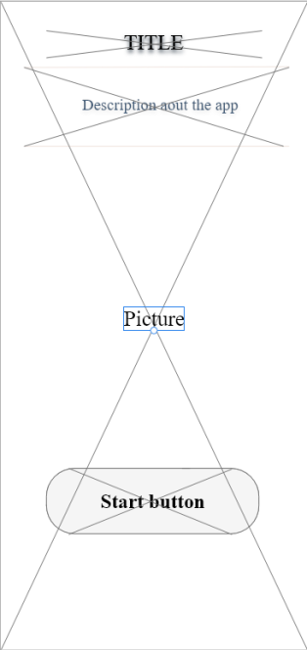

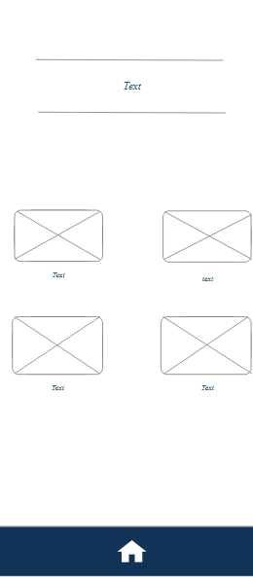

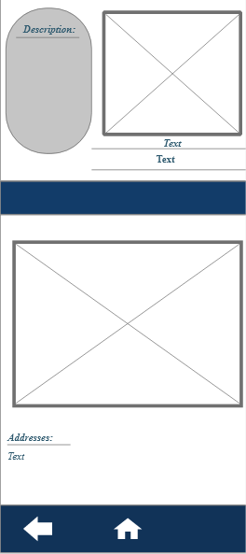

Finished Prototype:

<https://xd.adobe.com/view/90f9cc3a-1a41-4495-9246-5a3c706c3a7e-c5aa/>

We asked several people to review or prototype application this was their respond.

Summary:

Every person that reviewed our application said that it is very helpful and easy to use. Most of the users did not like the font on our first page and its readability and that is why we improved it a little.

Comment 1:

Thomas

The app looks really good and it's very helpful. One piece of feedback that I do have is that on the first slide the text in blue is a little hard to read. Otherwise it's very good.

Comment 2

Tony

The text on the first screen doesn't have enough readability. The leading line on the second page (the plane with the dots) seems like is connecting the first 2 categories and alienates the other 3 (Look into Gestalt Principals). As a whole, the readability and visual hiararchy needs to be improved. Good things about it: the design is consistent throughout all pages, the information architecture seems easy to understand by any user.

Comment 3

Velino

The application seems quite helpful and easy to use. The layout is consistent and does not flood the user with too much information at once. The colours are toned down and calming. A few small details that i believe could be touched on are the contrast levels, as some of the text has lower readability, as well as the spacing of the text panels inside some sections, as they may overlay or appear slightly cut. Other than that, it seems well made with a clear vision in mind.

Reflection :

At the beginning it was not easy to start even though we had a clear idea in mind .The thing that made us struggle a bit was the design part , we struggled with it because we wanted to me our design simple yet elegant and not over flooded. Yes we struggled but we managed to accomplish our idea( even though not fully) and bring it to life. In my opinion we can work on our prototype a little more in order to perfect it.

Designed by:

Group 3

Name: Katrin Tarneva -4162633 - PCB-06

Name: Kristian Kolev - 4154738 - PCB-06

Name: Neyko Neykov - 4150775- PCB-06

Name: Kristian Savov - 4170024 - PCB-06